

**Gulf Aluminium Rolling Mill B.S.C. (c)**

**ICT Department**

**CEA / MRE System**

*Software Requirement Specifications*

Document Revision History:

|  |  |  |  |
| --- | --- | --- | --- |
| **Version** | **Date** | **Remarks** | **Author** |
| 1.0 | 07 Feb 2023 | Draft created | Ervin Brosas |
|  |  |  |  |
|  |  |  |  |
|  |  |  |  |

Document Approval (Sign-off):

|  |  |  |  |
| --- | --- | --- | --- |
| **Approver Name** | **Position** | **Signature** | **Date** |
|  |  |  |  |
|  |  |  |  |
|  |  |  |  |
|  |  |  |  |

**Table of Contents**

1. Introduction 4

1.1. Purpose 4

1.2. Audience 4

1.3. Project Scope 4

1.3.1. Business Problem 4

1.3.2. Application Scope 5

1.3.3. Integration with Other Systems 5

2. Overall Description 5

2.1. Project Perspective 5

2.1.1. System Interface 6

2.1.2. User Interface 6

2.1.3. Software Interface 6

2.1.4. Hardware Interface 6

2.1.5. Memory Constraints 6

2.1.6. Operations 6

3. Specific Requirements 7

3.1. Functional Requirements 7

3.1.1. Budget Management 7

3.1.2. Expenditure Request Management 8

3.1.3. Expenditure Request Closure 13

3.1.4. Use Case 14

3.1.5. Web Forms 15

3.2. Performance Requirements 24

3.3. Design Constraints 24

3.4. Software System Attributes 24

3.4.1. Availability 24

3.4.2. Security 25

3.4.3. Maintainability 25

3.4.4. Portability 25

4. Change Management Process 25

# Introduction

## Purpose

This document delineates the different actors who will interact with the CEA System, the Project, as well as their corresponding requirements. Its purpose is to identify all main functionalities of the system which will guide developers in creating an effective software solution with detailed design and project development plan. It will also help end-users to evaluate their needs in obtaining a successful CEA electronic transaction.

In addition, this document will serve as the contract between the Project Team and the Project Stakeholders, stating what will be delivered according to the time constraints, risks, resources, and standards agreed upon for the implementation of the Project.

## Audience

This document is intended for Senior Management, Finance Team and Engineering Team for their perusal on various functionalities to be included in the Project as well as to identify any additional requirements that will boost the processing or routine of the system. This may also extend to Department Managers to get their feedbacks and needs for easy and smooth system operation.

This is also intended for Software Developers to provide the guidelines in designing the technical specifications of the Project in accordance to the requirements given by end-users.

## Project Scope

### Business Problem

The current CEA/MRE System is reaching its end-of-life due to its outdated technology and architecture. Though the system is still operational, the constant updates in internet browsers lead to several performance and operational issues, which have been reported by end-users. Maintaining the system using its current platform is cumbersome and challenging because of the unavailability of support for the 3th party tools used in the system.

### Application Scope

The CEA/MRE System will serve as the tool for submitting an expenditure request electronically. End-users will be able to track down the request any time online where they would be able to see its status and whom it’s currently assigned to. The system has built-in workflow engine that automates the approval process and sending of email notification to the approvers, as well as assigning to the substitute during their absence.

### Integration with Other Systems

The CEA/MRE System will receive information from the following external systems:

|  |  |
| --- | --- |
| JDE OneWorld | Information such as budget, cost centers, employee number/name, department managers, etc. |
| GARMCO Active Directory | User credential information such account name, user id, etc. |
| GAP | Employee leave information |

# Overall Description

## Project Perspective

The current CEA system, which is used for creating expenditure request electronically, has become outdated due to the advancements in browser technologies where the system could not cope-off. As a result, several system issues have been reported by end-users most notably with regards to the submission of a CEA request where the form has erratic behavior. These issues have been sorted out by turning on the browser compatibility mode to support legacy system such as the CEA application. Though, this has resolved the problem temporarily but will not be considered as a permanent solution because of the continuous updates in browser technology which could result in further degradation of the system.

With these facts in mind, the need to redesign the system using the latest development technologies is vital to eliminate all system operation issues and to ensure longer life span. The Project aims to develop a new system which will replace the current one and will cater all existing functionalities as well as implement new enhancements if necessary.

### System Interface

Integration with existing systems such as, JDE, TAS, and GAP.

### User Interface

End-users will interact with the system through a Graphical User Interface (GUI) that will be accessible using an internet browser such as, Edge, Chrome, or Firefox.

### Software Interface

The system will be developed using the following technologies: ASP.NET Core MVC, C#, Razor, TypeScript, HTML5, JavaScript, jQuery, AJAX, JSON, Bootstrap 5, CSS3, SASS, Font Awesome 5, Entity Framework Core, Dapper, Web API, T-SQL, and Visual Studio 2022.

### Hardware Interface

The system has no hardware interface requirements.

### Memory Constraints

The Project will be designed to work on any modern computers; any computer capable of running MS Windows 10/11.

### Operations

The modes of operation that will be implemented in the Project are as follow: Request Initiator, Originator, Approver, Secretary of CEO, and System Administrator.

1. Request Initiator
2. Creates an expenditure request by filling in the required information
3. Specifies the Originator who will validate the request
4. Specifies the Equipment No. to use, if required
5. Uploads file attachments
6. Allocates the schedule of expenses
7. Originator
8. Validates the accuracy of information provided in the expenditure request
9. Rejects the request if there is missing or wrong information
10. Approver
11. Approves or rejects the expenditure request
12. Secretary of CEO
    1. Uploads any completely approved requisition to JDE
    2. Closes the requisition to complete the life cycle
13. System Administrator
14. Uploads new projects into the system based on the Excel file given by the Executive Manager - Finance
15. Configures user’s access and overall system security

# Specific Requirements

## Functional Requirements

### Budget Management

The budget management function would help end-users to manage budget related information, which is used as a source in creating an expenditure request.

#### Creation of Projects

The Finance Department, at the beginning of fiscal year, will upload all approved CEA / MRE budgets into the system; conforming to the format (MS Excel sheet) defined by ICT Department.

The typical information included in the Excel sheet file are summarized in the following table:

|  |  |
| --- | --- |
| Field Name | Description |
| Fiscal Year | Refers to the financial year |
| Expenditure Type | Available options:   * CEA * MRE * INC |
| Cost Center | Refers to the department code |
| Project Number | Unique project reference number |
| Expense Category | Available options:   * MRE * Maintenance * Non-capital |
| Expense Description | Brief description about the project |
| Detailed Description | Detailed and full description about the project |
| Amount | Project cost in BD |
| Account Code | Cost Center account code |
| Object Code | Object account code |
| Subject Code | Subject account code |
| Company Code | Uses the following company codes:   * 100 - GARMCO Main Mill * 600 – GARMCO Foil Mill |
| Project Start Date | Expected project execution date |

Note that there are 3 types of expenditure request currently used in the system which include the following:

1. CEA – Capital Expenditure Addition
2. MRE – Major Revenue Expenditure
3. INC – Item Non-Capitalized

### Expenditure Request Management

This function provides a set of features for managing the expenditure request. The completed requisition will be uploaded to JDE OneWorld system, which can be used for creating a purchase requisition request.

#### Creating an Expenditure Request

The initiator will create an expenditure request by entering relevant information based on the project details. He/she will then select an item type, which can be any of the following types:

* Computer Related
* Human Resources
* Civil Engineering
* Mechanical Engineering
* Electrical Engineering
* Administration
* Transportation Related
* Furnitures and Stationaries
* Medical Related
* Safety Related
* Projects
* Office Equipment
* Quality Related
* Maintenance Related

Each item type is mapped to an approval group. Once all information is provided, the initiator will submit the request which will then trigger the workflow approval process. In addition, the system will facilitate the attachment of relevant external documents to the request. External documents can be attached only by the initiator or the department manager.

The system will check the available budget for the requested project. If the estimated cost in the current request exceeds the balance project budget amount, the system shall notify the initiator as well as the department manager. At this point, the initiator shall cancel the request or proceed with the request by filling the additional budget amount required and the justification for the additional budget requirement. A special note will be displayed in the approval form as well as in the printed form if an additional budget was requested.

The following approval process will take place after the submission of the expenditure request.

1. The request will be assigned to the Originator for approval. This person is selected by the initiator during submission of the request and is responsible for validating the accurateness of the provide information. The request can be rejected by him if any incorrect or missing information is found.
2. Once the Originator approves the request, it will be assigned for approval to the following roles within the department:
   1. Superintendent – refers to the Head of the department
   2. Cost Center Manager – refers to the Manager of the department

*(Notes: In some departments, the Superintendent and Cost Center Manager role refers to the same person. In such scenario, only one approval is required.)*

1. When the cost center approval process is done, the system will check if the request requires an “Item Category Approval”. This happens if the selected item type is mapped to an approver, which is summarized in the below table.

|  |  |
| --- | --- |
| Item Type | Approver |
| Administration | CEO |
| Civil Engineering | Executive Manager - Operations |
| Computer Related | Senior Group ICT Manager |
| Electrical Engineering | Exec. Manager - Operations |
| Furniture & Stationary | CEO |
| Human Resources | Executive Manager - Administration |
| Maintenance Related | CEO |
| Mechanical Engineering | Executive Manager - Operations |
| Medical Related | CEO |
| Office Equipments | CEO |
| Projects | CEO |
| Quality Related | CEO |
| Safety Related | Head of HSE |
| Transportation Related | Head of HSE |

1. In the next line of approval, the system will check if the cost center of the Originator, as specified in the request, belongs to any of the following Engineering departments:
   * + 3250 – ROLLGRINDING
     + 5200 – MECHANICALENGINEERING
     + 5300 – ELECTRICALENGINEERING
     + 5400 – CENTRAL ENGINEERING

If so, then the request will be assigned to the Executive Manager – Operations for approval. Otherwise, it will go to the next approver.

1. All request normally goes to the Executive Manager – Finance for approval regardless of cost center and budget amount.
2. After the approval of Executive Manager – Finance, the system checks if the expenditure request is budgeted and if the amount is greater than BD 20,000. If that is the case, the request will go to the General Manager for approval.
3. Next, the request will be assigned to the CEO for approval.
4. Then, the system checks if the amount is greater than BD 100,000. In that case, the request will go to the Chairman for approval.
5. Finally, after all approval is done, the request will be assigned to the Executive Personal Assistant for uploading the request to JDE OneWorld system.

In each approval stage, the system checks the Leave Requisition application to validate the availability of the assigned approver. If an approver is currently on-leave or not available for some reason, the workflow will assign the request automatically to their substitute if it’s defined either in the leave request or in the workflow substitute setup. Otherwise, it will be assigned to the original approver.

The following workflow diagram depicts the approval cycle from submission of a request until posting to JDE.

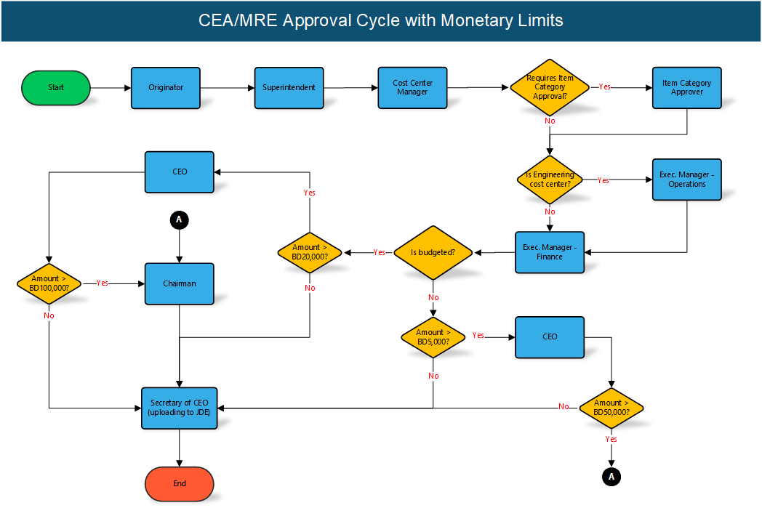

**Figure 1: CEA/MRE Workflow Approval Process**

#### Integration to Purchase Requisition system

Once the expenditure requisition is approved and posted to JDE, a Purchase Requisition request can be created to consume the CEA request. The PR system will automatically fetch the relevant information from the CEA system and display it in the data entry form.

#### Tracking of Expenditure Request

The system provides a facility to track the expenditure request in various statuses such as: Draft, Submitted for Approval, Awaiting Approval, In Queue, Awaiting Chairman Approval, Chairman Approved, Uploaded to JDE, Rejected, Cancelled, Closed, etc.

#### Maintenance of Completed CEA

The Finance Department will have the functionality to close any completed Projects and CEA requests for specific fiscal year. No CEA request can be created against a close or cancelled Project. Likewise, no Purchase Requisition request can be created against a closed or cancelled CEA/MRE request.

#### Validations

The full report about the expenditure request can only be printed if the approval process is completed.

#### Non-functional

All entries and user actions will be logged into the database for audit purposes.

### Expenditure Request Closure

This function provides a set of features for closing an expenditure request. The completed requisition will be uploaded to JDE OneWorld system, which can be used for creating a purchase requisition request.

#### Creating an Expenditure Request

The initiator will create an expenditure request by entering relevant information based on the project details.

### Use Case

This Use Case diagram shows the different actors that will be involved in the expenditure request processing and their corresponding functions. Its main objective is to capture behavioral aspect of the system from a user’s point of view.

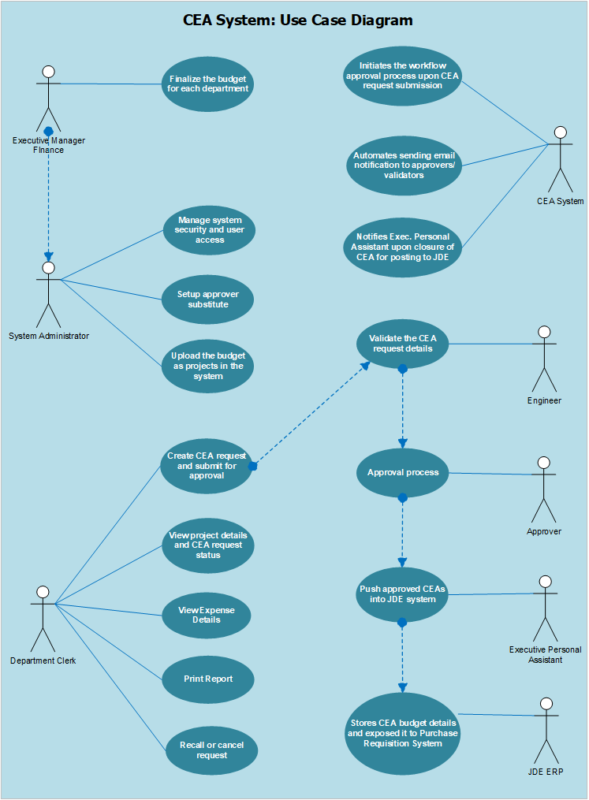

**Figure 2: Use Case Diagram**

### Web Forms

The following user interface form prototypes will be provided to end-users for interacting with the system.

#### Project Inquiry

This form will be used to search the database for all projects based on predefined filter criteria. Information such as, Project No., Project Date, Expenditure Type, Description, Detailed Description, Account No., Status, and Project Amount will be shown in the grid. There will be a link to create new expenditure request for the desired project as well as to view the project details.

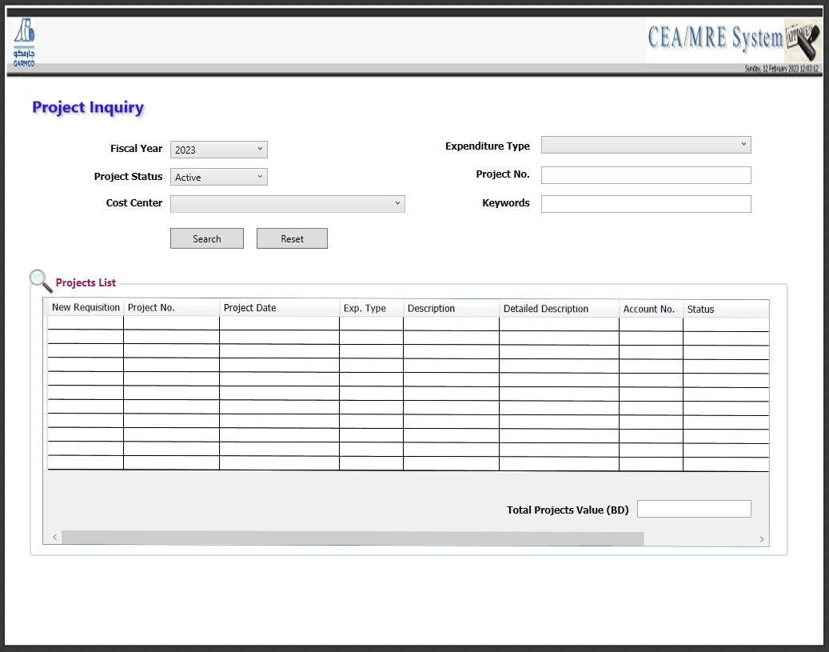

**Figure 3: Project Inquiry form**

#### Project Details View

This form will be used to view the full details of the project as well as to update the following information if required:

* ***Account No.*** – refers to the combination of account code, object code, and subject code
* ***Cost Center*** – the department that owns the project
* ***Expenditure Type*** – can be any of the following types: Capital Expenditure Approval (CEA), Item Non-Capitalized (INC), Major Revenue Expenditure (MRE), and Spares
* ***Budgeted Project Amount*** – the amount allocated for the project
* ***Description*** – brief description about the project
* ***Detailed Description*** – full description of the project
* ***Expected Project Date*** – refers to the commencement date of the project

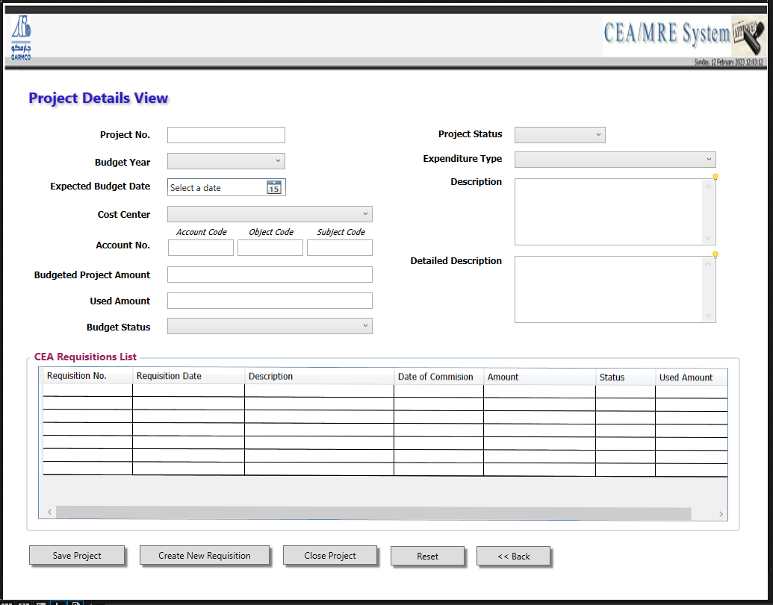

**Figure 4: Project Details View form**

#### Requisition Inquiry

This form will be used to search the database for all expenditure requisitions created based on specific search filter criteria. The following links will be visible on the grid to view other information related to the request:

* ***Project No. link*** – this will open the “Project Details View” form to show the full details about the selected project
* ***Requisition No. link*** – this will open the “Requisition Details View” form which shows the complete information about the submitted expenditure request
* ***Status link*** – this will open the “Requisition Status View” form which shows the workflow approval history
* ***View Expenses link*** – this will open the “Requisition Expenses View” form which shows the list of all purchase orders created for this CEA request

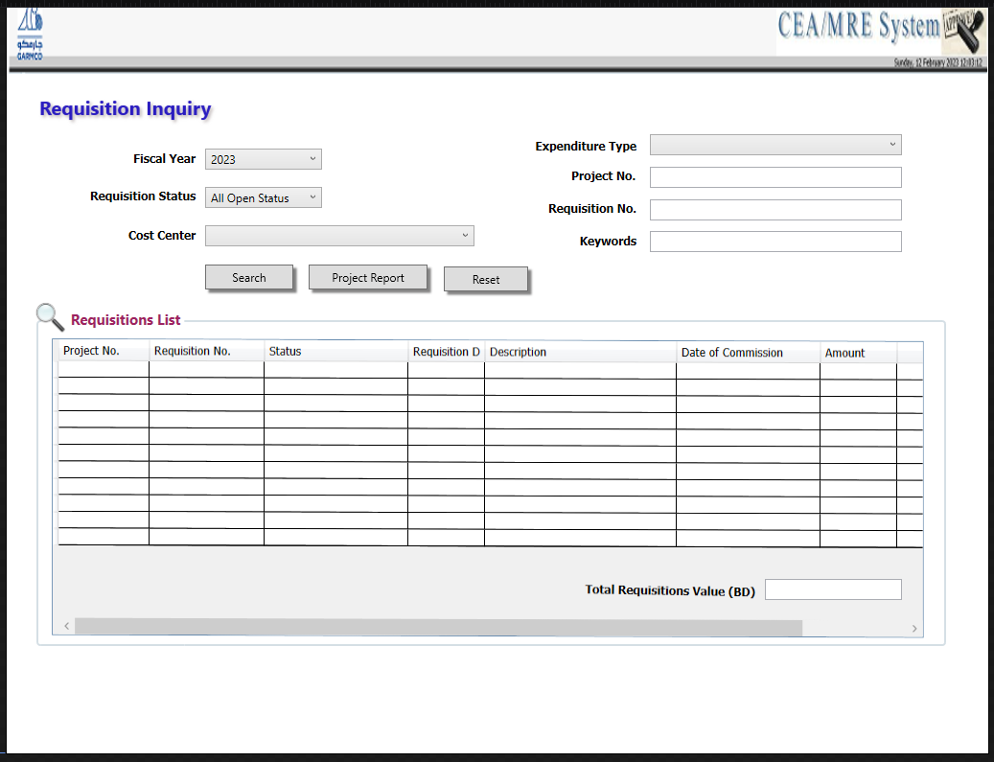

**Figure 5: Requisition Inquiry form**

#### Requisition Details View

This is the data entry form for submitting a new expenditure request. This is also the form being used to show the complete details of an already submitted requisition. A sample layout of the form is shown below as well as the description of each data entry fields:

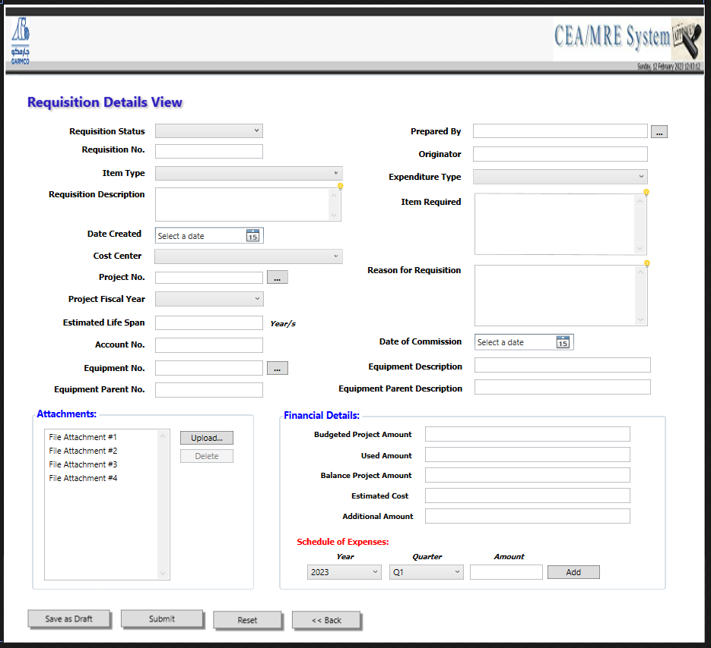

**Figure 6: Requisition Details View form**

**Data Entry Fields:**

|  |  |
| --- | --- |
| Field Name | Description |
| *Item Type* | Refers to the type of request which can be any of the following. *(Note: This field is mandatory and cannot be left blank or unspecified.)*   * Computer Related * Human Resources * Civil Engineering * Mechanical Engineering * Electrical Engineering * Administration * Transportation Related * Furnitures and Stationaries * Medical Related * Safety Related * Projects * Office Equipment * Quality Related * Maintenance Related |
| *Requisition Description* | A brief description about the expenditure request. *(Note: This field is mandatory and cannot be left blank or unspecified.)* |
| *Date* | Refers to the creation date of the request, and the value is populated automatically from the system’s current date. The date can be changed to any value prior to submission. |
| *Cost Center* | Refers to the charged cost center of the expenditure request. Data is automatically fetch based on the cost center defined for the selected project, where the request is being created. *(Note: This field is locked when creating a new requisition)* |
| *Project No.* | Refers to the unique project number where the requisition is being mapped to. *(Note: This field is locked when creating a new requisition)* |
| *Project Fiscal Year* | Refers to the fiscal year as defined in the project details. *(Note: This field is locked when creating a new requisition)* |
| *Estimated Life Span* | Refers to the duration or lifetime of the project |
| *Account No.* | Displays the account number defined for the selected project where the expenditure request is being created. The number is a combination of the cost center, object account code, and subject account code. *(Note: This field is locked when creating a new requisition)* |
| *Equipment No.* | Displays the unique reference number of the selected equipment |
| *Equipment Description* | Displays the brief description of the selected equipment |
| *Prepared By* | Refers to the name of employee who has initiated the request. Information is fetched from the Employee Master in JDE based on the current logged-on user. |
| *Originator* | Refers to the person who will validate the details contained in the expenditure request. *(Note: This field is mandatory and cannot be left blank or unspecified.)* |
| *Expenditure Type* | Refers to the type of expenditure request which can be any of the following:   * CEA – Capital Expenditure Addition * MRE – Major Revenue Expenditure * INC – Item Non-Capitalized |
| *Item Required* | Provide details of the items which will be purchased or consumed within the project duration |
| *Reason for Requisition* | Refers to the reason or justification why the expenditure request was created. |
| *Date of Commission* | Refers to the commencement date of the project |
| *Attachment* | Allows end-user to add file attachments which will serve as supporting documents for the requisition. |
| *Financial Details* | Contains information about the project budget amount, used amount, balance project amount, additional amount, and the schedule of expenses. |

#### Requisition Status View

This is where end-users can see the current approval status of the submitted expenditure request. Information such as name of the approver, approval level, approval date, comments, and current status will be shown on the grid.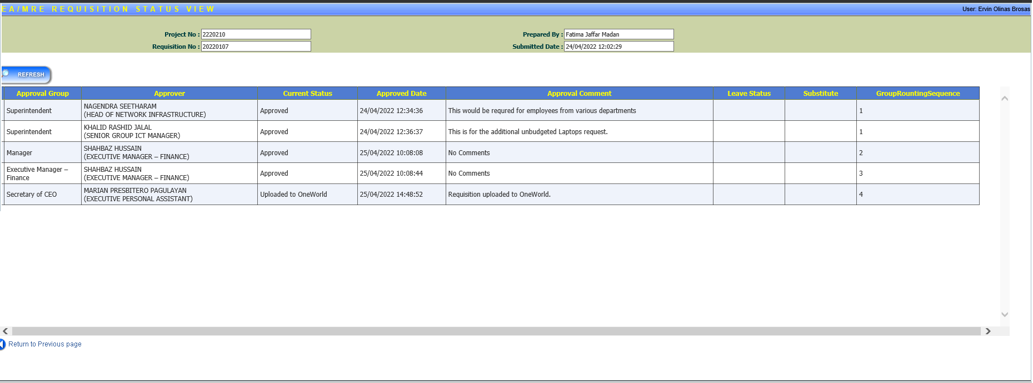

**Figure 7: Workflow Approval Status View form**

#### Requisition Expenses View

This form provides the list of all purchase order requests created for the associated CEA requisition. Information such as total CEA requisition amount, total PO amount, total GL amount, and total requisition balance will be shown at the footer section of the page.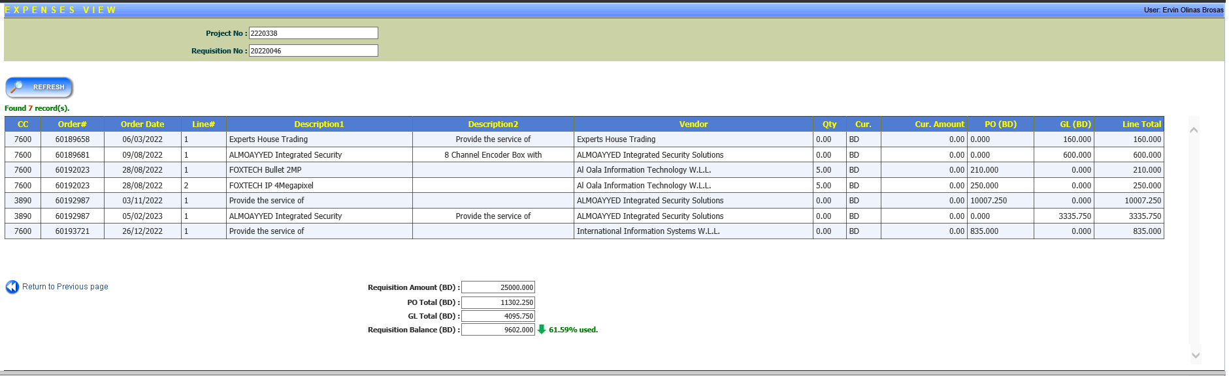

**Figure 8: Expenses View form**

#### Requisition Status Management

This form is used to change the status of the CEA requisition, which is accessible only to authorized users. It is also used when recalling or cancelling an already submitted expenditure request.

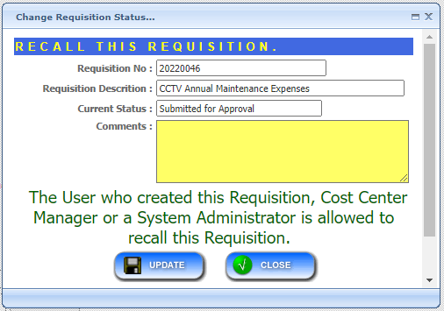

**Figure 9: Change Requisition Status form**

#### Employee Lookup

This form is used to search for the desired Originator employee, which is a required field, when submitting an expenditure request. Information shown in this form depends on the cost center access permission given to the current logged-on user.

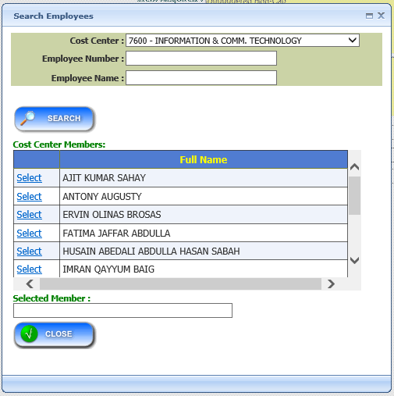

**Figure 10: Employee Search form**

#### Equipment Lookup

This form is used to search for an equipment from the list of registered items in the Equipment Master table in JDE. Information such as equipment number, description, parent equipment number, and parent equipment description will be shown in the grid.

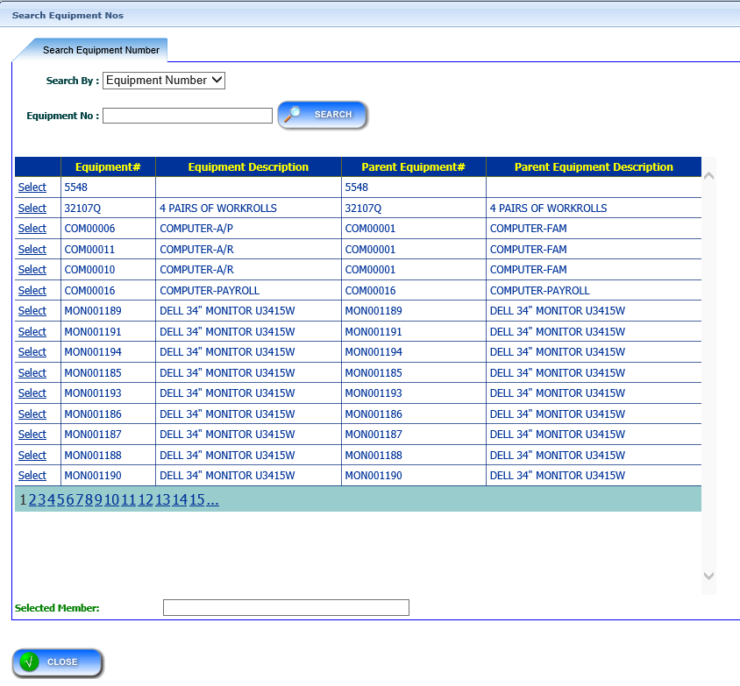

**Figure 11: Equipment Search form**

#### Upload Attachment

This form is used to add and upload file attachments that will be associated with the expenditure request. There is no limit to the number of attachments that can be added in the system, but the file size is limited to 5 MB only. End-users can upload 1 file at a time and then, submit it all at once.

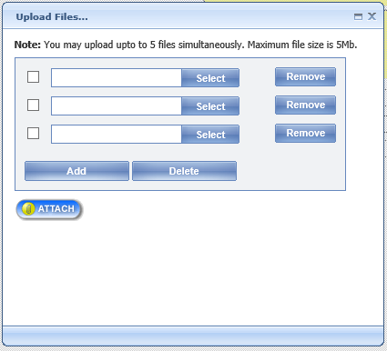

**Figure 12: Upload File Attachment form**

## Performance Requirements

## Design Constraints

The Project will be developed using MS Visual Studio 2022 Enterprise Edition and MS SQL Server 2019 as the database backend. The host environment must have the following minimum requirements:

1. MS Windows Server 2019
2. .NET Framework 4.5

## Software System Attributes

### Availability

Any changes made within the system will be tested on a separate server environment before deploying to production server. In addition, all users will be notified through email regarding any updates so not to impede with their current operation. No necessary reinstallation will be done on users’ side.

### Security

To maintain confidentially of data, Windows Domain Account will be used to access the system. This will save users for keeping additional accounts.

### Maintainability

The Project will be developed using the well-known architectural pattern called Model-View-Controller (MVC) to ensure an easily maintainable system.

### Portability

Portability is one of the premier points of the Project for it will not be highly dependent on users’ computer specification but rather on the server.

# Change Management Process

Significant changes to the software requirements document shall be only be made when it is the consensus of the group that they are necessary and feasible. Any changes that will be included after the approval of this document will be treated as an enhancement request which requires a Helpdesk ticket to be raised by the concerned party. This is to ensure that development process will not be interrupted, and the targeted project deadline will be met.

# Administrative Functions

5.1 *Requisition Posting/Closure Management*

This form will be used to search requisition details of the cost center based on year, expenditure type etc. The details of the individual search filter and corresponding description are in the following tables.

**Search Criteria:**

|  |  |
| --- | --- |
| Field Name | Description |
| *****Cost Center***** | Refers to the unique reference Name that will be used to identify the Cost Center in the system. This field allows to find matching the specific records based on the Cost Center. |
| *Fiscal Year* | Find matching records based on specific period |
| *Project Status* | Find matching records based on the selected status. |
| *Expenditure Type* | Find matching records based on the Expenditure Type in the System. |
| *Requisition No* | Find matching records based on the requisition Number in the System. |
| *Project No* | Find matching records based on the Project number. |

A sample layout of the form is shown in the below screenshot,

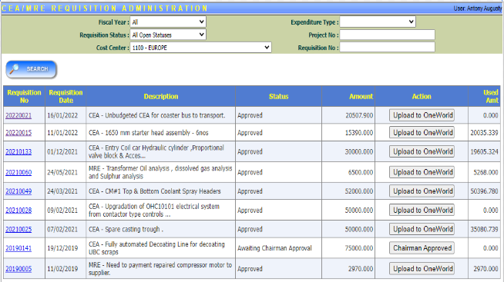

The details of the output fields and corresponding description are in the following tables.

**Output Data fields:**

|  |  |
| --- | --- |
| Field Name | Description |
| *Requisition No* | Refers to the unique requisition number for request. |
| *Requisition Date* | Refer the date of requisition. |
| *Description* | Description about the requests. |
| *Status* | Current status of the requests. |
| *Amount* | Requested amount |
| *Action* | Upload data to the JDE |
| *Used Amount* | Details about the amount used. |

5.2 *Equipment Number Assignment*

This form will be used to assign the equipment number to individual requisition. Projects data will be displayed as tabular format with requests for assigning equipment number and the corresponding ‘Select’ link to view the requisition details for each Project Number. Search Equipment button can select the equipment from the popup window. End user can view the requisition details and equipment number details based on Project number selection.

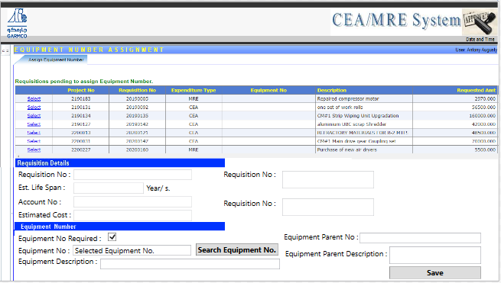

5.3Upload Project Setup

User can upload the budget excel file into the system through Upload file button and user can view the uploaded file in the tabular format using View Projects button. The end user can save the uploaded file using ‘Save Uploaded Projects’ button and user can delete the uploaded file using ‘Delete uploaded Project’ button.

# Report Functions

6.1 Detailed Expenses Report

This report is used to view the details about the Expenditure/ Budget based on the Cost Center, Fiscal Year, Project Status, Expenditure Type and Requisition Status. The details of the individual search filter and corresponding description are in the following tables.

**Search Criteria:**

|  |  |
| --- | --- |
| Field Name | Description |
| *****Cost Center***** | Refers to the unique reference Name that will be used to identify the Cost Center in the system. This field allows to find matching the specific records based on the Cost Center. |
| *Fiscal Year* | Find matching records based on specific period |
| *Project Status* | Find matching records based on the selected status. |
| *Expenditure Type* | Find matching records based on the Expenditure Type in the System. |
| *Requisition Status* | Find matching records based on the requisition status in the System. |
| *View Report* | To generate the search data based on the selected search criteria. |
| *View Report in Excel* | To download the search data as excel sheet based on the selected search criteria. |

A sample layout of the form is shown in the below screenshot,

The details of the search result and corresponding description are in the following tables.

**Search Result:**

|  |  |
| --- | --- |
| Field Name | Description |
| Project | Details about the Project |
| ***No*** | Project Reference Number |
| ***Cost Center*** | Cost Center Identification Number |
| *Fiscal Year* | Financial Year detail. |
| *Description* | Description about the Budget. |
| *Expenditure Type* | Details about the Expenditure Type |
| *Budget* | Budget Details. |
| *Status* | Status about the project, whether project is closed or Active. |
| Requisition | Details about the Requestion |
| ***No*** | Requestion Reference Number |
| *Description* | Description about the Requestion |
| *Budget* | Requestion Budget amount |
| *Status* | Status of the Requestion |
| Purchase Order | Details about the PO |
| *No* | PO Number |
| *Line Number* | PO Line Number |
| *Voucher* | Voucher details about the Request |
| *No* | Voucher number |
| *Type* | Voucher Type |
| *Paid Amount* | Amount paid for the request |
| *Item Number* | Item Number |
| *Currency* | Currency details |
| Payment | Payment details about the Request |
| *No* | Payment number |
| *Date* | Date of the payment |
| *Document Type* | Document Type of the Requests |
| *Actual Paid amount* | Shows the paid amount for the request |

6.2 Expense Report

This report is used to view the details about the Expenditure/ Budget based on the Cost Center, Fiscal Year, Project Status, Expenditure Type and Requisition Status. The available data will be displayed on a grid in the tabular format. The details of the individual search filter and corresponding description are in the following tables.

**Search Criteria:**

|  |  |
| --- | --- |
| Field Name | Description |
| *****Cost Center***** | Refers to the unique reference Name that will be used to identify the Cost Center in the system. This field allows to find matching the specific records based on the Cost Center. |
| *Fiscal Year* | Find matching records based on specific period |
| *Project Status* | Find matching records based on the selected status. |
| *Expenditure Type* | Find matching records based on the Expenditure Type in the System. |
| *Requisition Status* | Find matching records based on the requisition status in the System. |
| *View Report* | To generate the search data based on the selected search criteria. |
| *View Report in Excel* | To download the search data as excel sheet based on the selected search criteria. |

A sample layout of the expense report form is shown in the below screenshot,

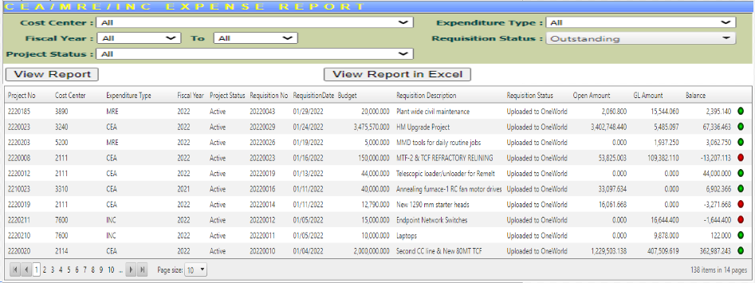

6.3 Requisitions Report

This report is used to view the details about the Requisition Status of the Expenditure requests based on the Requisition Status, Fiscal Year, Expenditure Type and Cost Center. The available data will be displayed on a grid in the tabular format. The details of the individual search filter and corresponding description are in the following tables.

**Search Criteria:**

|  |  |
| --- | --- |
| Field Name | Description |
| *****Cost Center***** | Refers to the unique reference Name that will be used to identify the Cost Center in the system. This field allows to find matching the specific records based on the Cost Center. |
| *Fiscal Year* | Find matching records based on specific period |
| *Requisition Status* | Find matching records based on the selected requisition status. |
| *Expenditure Type* | Find matching records based on the Expenditure Type in the System. |
| *Requisition No.* | To generate the search data based on the selected requisition number. |
| *keywords* | To search method to filter the data based on the keywords |

A sample layout of the expense report form is shown in the below screenshot, The ‘View Report’ button in the output table can view the requisition details of individual project number in the system.

